Logbook 1 Template (for offline log preparation)
Name: | Kaung Linn Aung
Week Date: | Part A -Meeting 1 of 8
(The above information is for you to keep track of which week this log is applicable for. This information is not required in the online logbook as the system will find your name, your supervisor’s name, and take the submission date, automatically. You must submit the online log in the relevant week. Logs cannot be backdated to missed weeks.)

Meeting date:  (please note if no meeting is planned this week) | Date and day  28/5/2026
Work Undertaken this week:  (No more than 4000 characters, including spaces) | From the project title that you have selected, do a research on similar projects ( at least 4) and summarize your finding on each one.  (1) Project 1: Max Imagination's ESP-DIVE (Instructables)  Findings: A great open source FPV RC submarine for about $125. It shows how to make a low-cost, active buoyancy ballast system with standard medical syringes powered by N20 micro-geared motors. It also uses inductive wireless charging to ensure that the hull is permanently sealed, greatly minimizing the risk of leakage over time.  (2)Project 2: BlueROV2 (Commercial Baseline)  Findings: An industry standard underwater platform for multi-axis motion with a vectored thruster configuration. It is very reliable, but commercially priced parts are too expensive for our budget. Its architectural design, however, does show that individual electronic speed controllers (ESCs) to drive brushless motors offer the greatest structural agility for subsurface scanning.  (3)Project 3: HippoCampus AUV (Technical University of Hamburg)  Findings: Micro-AUV designed specifically for test-tank environments. This project is very dependent on 3D printed structural parts and internal equipment sleds. It points out that 3D-printed plastics (such as PETG) are well suited for quick and inexpensive prototyping in university labs.  (4)Project 4: Edge-AI Marine Inspection Frameworks (Academic Literature)  Findings: Research papers on autonomous debris and structural anomaly detection with compact single-board computers. It has been proven in the literature that lightweight computer vision models (e.g., OpenCV or TensorFlow Lite) can be used to process real-time video streams for subsurface object identification on a Raspberry Pi.t 1: Max Imagination's ESP-DIVE (Instructables)
Problems encountered:  (No more than 4000 characters, including spaces) | What is the information that are not clear or sufficient for your intended project. If no, you can skip this.  Strict Budget vs. Component Costs: Commercial underwater thrusters and waterproof acrylic enclosures are too costly. The technical challenge here is to waterproof a low-cost, off-the-shelf drone brushless motor, and to modify standard PVC plumbing pipes to be used for the main pressure hull.  Dual-Processor Processing & Communication: The original ESP-DIVE architecture uses just one microcontroller for basic functions. I need more than one microcontroller for my project, since I need to analyze the frames and keep logging the video using AI. The problem is to find an efficient and low latency communication channel (internal serial/UART) between a Raspberry Pi (the higher level brain) and an ESP32 (the motor driving slave).  Hull Volume Allocations: To keep the Raspberry Pi, ESP32, ESC modules, buck converters and the dual-syringe ballast assembly side by side without overheating, it is necessary to scale up the physical footprint from a thin acrylic tube to a larger chassis.
Tasks agreed for upcoming week:  (No more than 4000 characters, including spaces) | What are your plan actions/task until the next progress meeting.  Task 1: Component Procurement Matrix & Cost Analysis  All required electronics, sensors and structural components will be itemized and a finalized list will be created and compared to the available inventory in the university Electronics and Mechanical Lab to minimize external costs.  Task 2: Conceptual 2D/3D Hull Layout & Sizing  Initial structural designs of the pressure hull will be created in design software to determine the required diameter of the main PVC/acrylic tube for the internal equipment sled.  The system hardware and software communication protocol architecture is built.System hardware and software communication protocol architecture is constructed.  The data packet structure for autonomous navigation commands to be sent from the master processor (Raspberry Pi) to the slave microcontroller (ESP32) will be conceptualized.  Task 4: Safety & Regulatory Literature Review.  The standard safety operating procedures for the use of Lithium-Polymer (LiPo) batteries in enclosed waterproof areas will be reviewed to meet project regulatory requirements.
Figures:  (Upload image files in the online Log Form, but feel free to keep notes here about which images you intend to upload. Use “Figure Caption” information as the filenames, e.g., “Figure 1 – A screenshot of the initial constrained Sketch in CATIA.jpg”) | - Provide / Sketch an artistic view of your project. A rough one will do. You can use any software like PPT to design this sketch  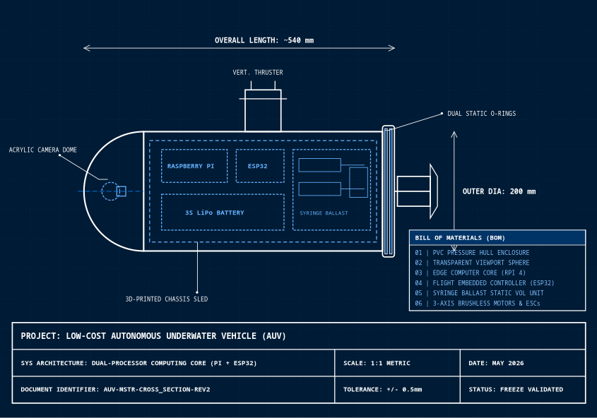  - Update Block diagram of your system  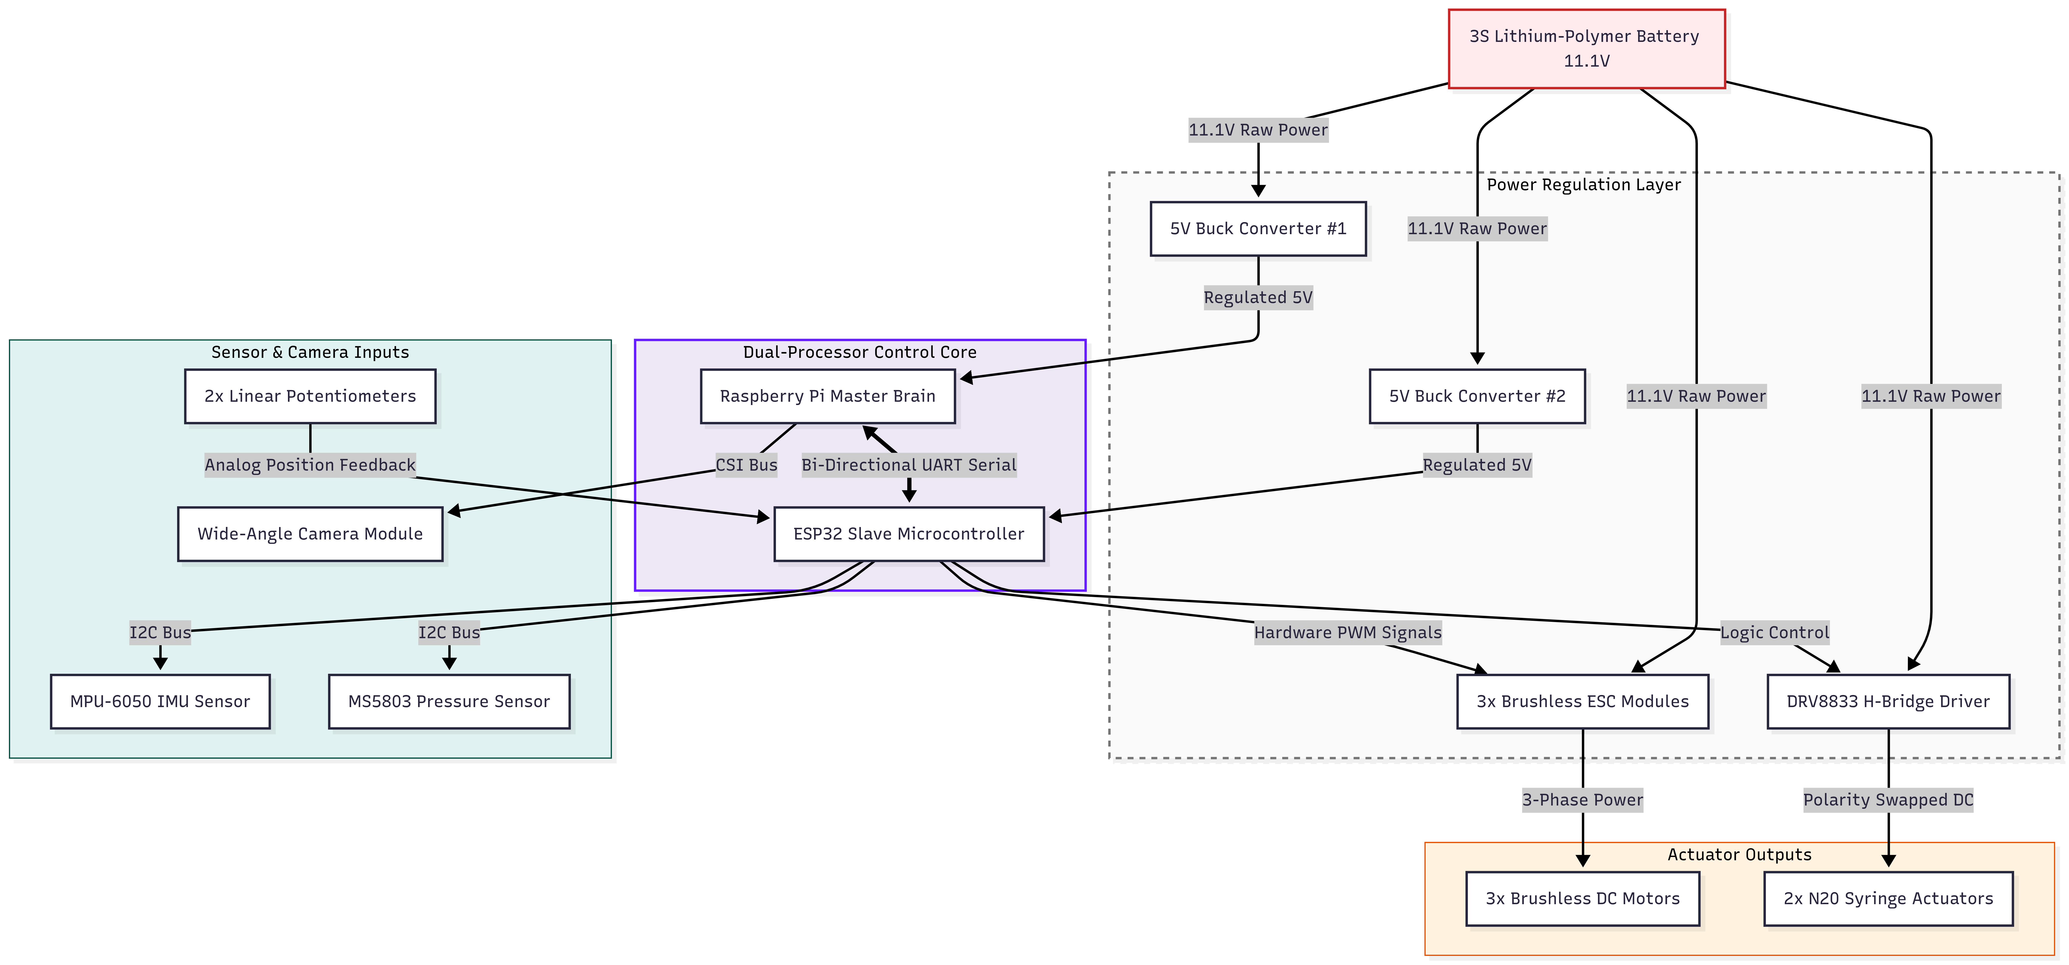  - Key software codes/modules that need to be developed  Module 1: Autonomous Mission Planner Loop (Python Based)To execute the pre-programmed state machine (e.g., timed forward propulsion, targeted depth hold and safety return to surface routines).  Module 2: Edge-AI Object & Anomaly Detection: This module analyzes the video frames received from the camera module using lightweight OpenCV or TensorFlow Lite frameworks to detect objects and anomalies. This module is used to detect anomalies, structural cracks or pre-defined anomalies during subsurface infrastructure inspections.  Module 3: Data Logging & Telemetry Serialization - Simultaneously logs and writes high-definition video streams to the MicroSD card, while serializing operational telemetry data for post-mission analysis.ESP32 Slave Firmware Stack (C++/Arduino-Based)  Module 4: I2C Sensor Fusion & Data Filtering Polls low level, high frequency I2C sensors of MPU-6050 IMU and MS5803 pressure sensors. It uses digital filtering algorithms to give noise-free orientation and depth measurements.  Module 5: Closed-Loop PID Depth & Attitude Regulation: Performs a Proportional-Integral-Derivative (PID) control algorithm to dynamically control buoyancy and thruster outputs. The depth error inputs are used in the following equation to calculate the control output u(t) :  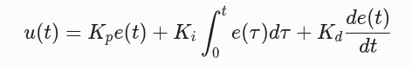  Module 6: UART Serial Packet Parser Decodes incoming movement commands from the Raspberry Pi and sends out compiled sensor packets back over the internal communication link.  - Any Quality and Regulatory issued to be addressed?  - Electrical Integrity & Containment Safety: The Lithium-Polymer (LiPo) battery is completely sealed in an unvented PVC pressure hull, so risk management procedures need to be created to ensure that the battery will not heat up or generate toxic gases. The physical fuse links and battery telemetry monitoring should be combined.  - Environmental Compliance Constraints: All waterproofing agents (marine grease, epoxy potting, etc.) should be tested to ensure they are chemically inert and non-toxic for use in test tanks to prevent water pollution.  - Operational Leak Mitigation: A structural quality requirement involves placing a localized hardware moisture sensor at the lowest physical point of the internal 3D-printed equipment sled. An automatic override command is sent to the syringe ballast to remove the water if it is detected, to ensure a safe surfacing of the vehicle.

